Order Of Service

Singing: Psalm 30—CW page 76

Reading: Psalm 106:24-31

Opening Hymn: TLH 286

Reading: Acts 24:1-9

Request Hymn: CW Supplement 716

Reading: Matthew 10:34-39

Sermon Hymn: TLH 285

Sermon Text: Mark 10:13-16

Blessing Little Children

Prayer

The Apostles’ Creed, TLH page 12

Holy Communion

The Lord's Prayer

The Blessing

Closing Hymn: TLH 52

* * * * * * * * * * *

Bible Study: Lambs: Weasel
Sheep: Proverbs 20:16-20
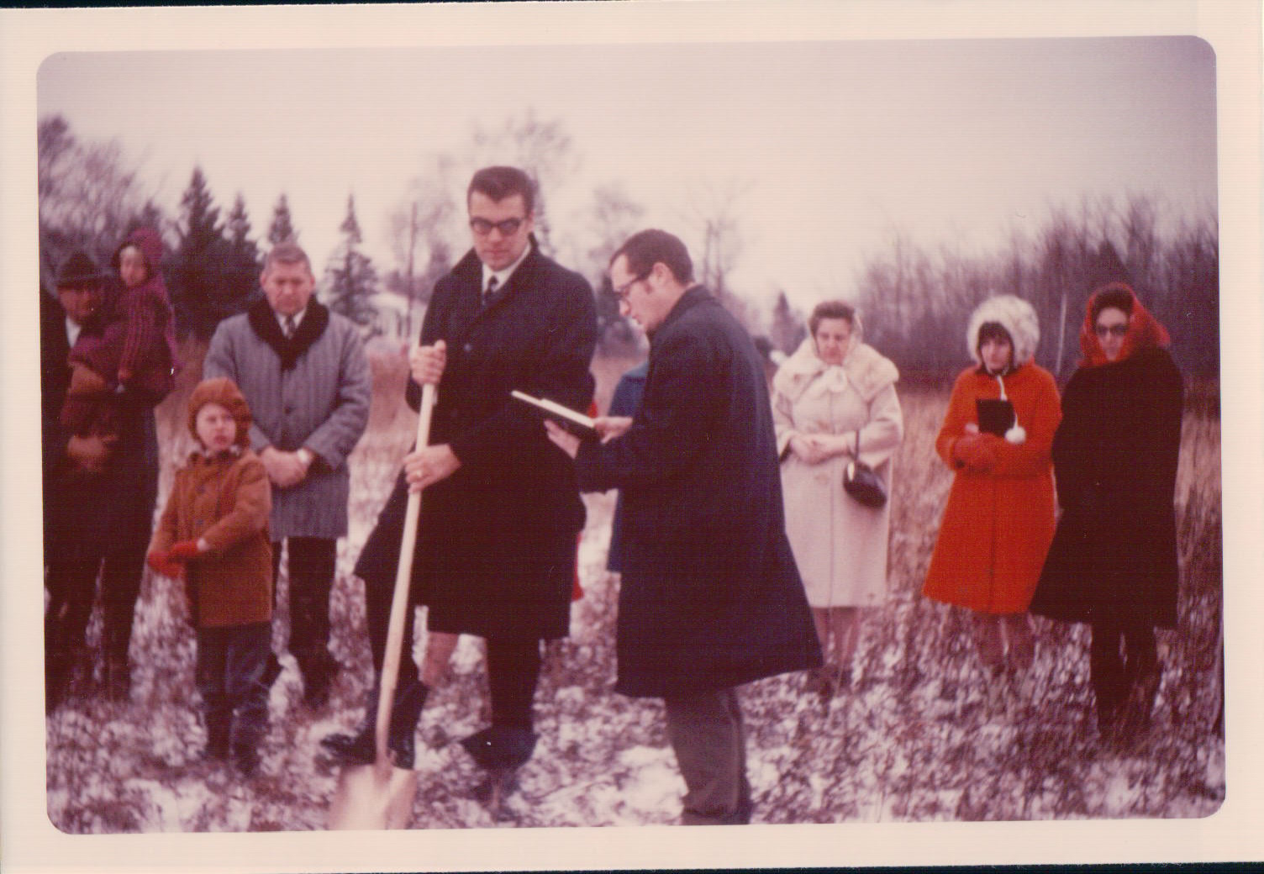

Starting To Dig—Duluth, MN

Water
Of
Life
13 October 2019

W A T E R O F L I F E

Independent Christian Church—Conservative Lutheran Doctrine

Worship Service: 9:30 a.m. Bible Study: 10:45 a.m.

Larry Cooper, Pastor E-Mail address:
111 N. Ridge Road lcooper@wateroflife.cc
Coon Valley, WI 54623 Web Site:
www.wateroflife.cc

* * * * * * * * * * * * * * * * * * * * * * * * * * *

Sermon Text: Mark 10:13-16

Blessing Little Children

* * * * * * * * * * * * * * * * * * * * * * * * * * *

Mark 10:13 And they brought young children to him, that he should touch them: and his disciples rebuked those that brought them.
:14 But when Jesus saw it, he was much displeased, and said unto them, Suffer the little children to come unto me, and forbid them not: for of such is the kingdom of God.
:15 Verily I say unto you, Whosoever shall not receive the kingdom of God as a little child, he shall not enter therein.
:16 And he took them up in his arms, put his hands upon them, and blessed them.

Psalm 127

Psalm 127:1 Except the LORD build the house, they labour in vain that build it: except the LORD keep the city, the watchman waketh but in vain.
:2 It is vain for you to rise up early, to sit up late, to eat the bread of sorrows: for so he giveth his beloved sleep.
:3 Lo, children are an heritage of the LORD: and the fruit of the womb is his reward.
:4 As arrows are in the hand of a mighty man; so are children of the youth.
:5 Happy is the man that hath his quiver full of them: they shall not be ashamed, but they shall speak with the enemies in the gate.

Psalm 128

Psalm 128:1 Blessed is every one that feareth the LORD; that walketh in his ways.
:2 For thou shalt eat the labour of thine hands: happy shalt thou be, and it shall be well with thee.
:3 Thy wife shall be as a fruitful vine by the sides of thine house: thy children like olive plants round about thy table.
:4 Behold, that thus shall the man be blessed that feareth the LORD.
:5 The LORD shall bless thee out of Zion: and thou shalt see the good of Jerusalem all the days of thy life.
:6 Yea, thou shalt see thy children's children, and peace upon Israel.

